A Contribution to Philosophy of Knowledge

Historical roots of words

Words are structural elements for composing language − arguably one of the principal defining characteristic of humans. The neurobiological basis of our ability to listen, speak and comprehend is not sufficiently understood and the questions about language evolution still evoke heated controversy in the cognitive sciences, humanities, and even in applied branches such as knowledge engineering and information technology.

Prehistoric man has undergone a millennia long evolution before articulating first words. Fully human speech anatomy first appears in the fossil record in the Upper Paleolitic (about 50,000 years ago) and was absent in both Neanderthals and earlier humans. In a way, the development of speech capability in infants reproduces this evolution at a fascinating neurobiological acceleration. A newborn baby seems to be able to learn and even express itself before uttering a single word. Words are media of thought, but they are not the thoughts themselves.

Our knowledge about the evolution of words relies predominantly on studies exploring the development of words and writing such as etymology and philology. Historically, writing is subsequent to speech and presupposes it. Aristotle expressed the relation thus: speech is the representation of the mental experiences, and writing is the representation of speech.

Prehistoric humans probably communicated by gesturing, squalling and yelling before they articulated first words. The sounds chosen for the first words were likely onomatopoeic, and the words such as “roar” (lion) and “purr” (cat) become recognised. The variations of the words such as “mum” can be explained by the easy of vocalisation, and so on. Many early words were probably contractions of two or more original words. Soon the words become more than just imitative noises, and etymology uncovers convincingly meaningful roots for words in human languages.

The following stage – writing – appears to have evolved from an extension of pictures: signs that directly and iconically represented some thing or action and then the word that bore that meaning (Figure 1).

Figure 1: Prehistoric drawings [1]

This approach opened the way for whole spectrum of so-called pictographic/ideographic writing systems which are likely antecedents for the oldest continuously used systems of writing in the world: Chinese characters (and its Japanese, Korean and Vietnamese mutations). In this system each word is graphically represented by a separate symbol or by a sequence of such symbols, Figure 2 [2, 9].
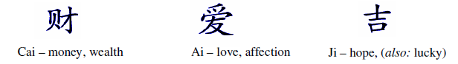

Figure 2: Chinese ideograms

The whole spectrum of logographic writing systems followed the variety of the evolution of human civilisations and cultures. Chinese character writing has for many centuries been stylized, but it still bears marks of the pictorial origin. Such character writing is laborious to learn and imposes a burden on the memory. Alternative to it are segmental scripts dominated today by alphabetic writing.

The Greek alphabet came from the Phoenician script, a syllabic-type writing system that indicated the consonant sounds. The great innovation of Greek culture, the driving force behind the flowering of Greek philosophy, mathematics, science and culture was the addition of letters to represent the sounds of vowels [3]. Before that, phonetically written languages provided letters only for consonant sounds. This led to a great deal of ambiguity in written text as readers had to interpret the letters and decide which vowel sounds to add, and where to add them. In Hebrew, this led to a culture of commentary on commentary on sacred texts. Authoritative Early Christian texts were written in Greek placing somewhat less demand on their interpretation. Another effect of Greek alphabetic writing was that the written language could immediately mirror changes in spoken language, and writers could coin new words that readers could pronounce unambiguously.

Thus the new alphabetic Greek writing was a technique that ‘standardised’ words, removed ambiguity from writing; that is the quest expressed in this discourse. This new technique of the alphabet also made writing dynamic and contemporary − an effect parallel to information technology developments in our time. We must ask ourselves whether removal of ambiguity and introduction of dynamic sharing of knowledge by means of information technology can lead to another great flowering of human culture.

The Greek alphabet spread over the ancient world, undergoing numerous changes. From a Western version sprang the Latin (Roman) alphabet. Also derived from the Greek alphabet, the Cyrillic alphabet was devised
in the 9th century. [2]

Arabic alphabet is specific in that it is written from right to left, in a cursive style, and its 28 letters usually stand for consonants. However, in the learned Arabic grammar script the vowels are used and they are crucial to the grammar.

Examples of Arabic, Greek, Cyrillic and Latin alphanumeric symbols are shown in Figure 3 (note the name “Arabic” for ciphers used in English; in fact this system can be traced to Hindu mathematicians who also invented both the notion of and the symbol for value/amount ‘zero’).

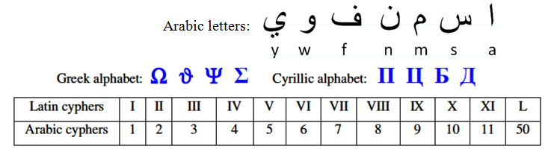

Figure 3: Examples of alphanumeric symbols

Contemporary Japanese employs a mixed system, broadly representing the roots of words by Chinese characters and the inflectional endings by syllable signs.

Knowledge is largely (but not exclusively) recorded and shared in textual form. Vocabulary and syntax are complex constructs, and inasmuch as there is an obvious link between grammar and logics, much remains to be understood.

For the sake of indicating the diversity of means used for recording text, numbers and sound, three contemporary systems of symbols are presented in Figures 4 to 6.
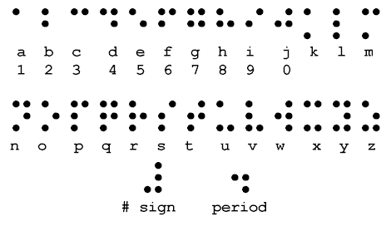

Figure 4: The Braille characters (embossed on paper and read by passing the fingers over the manuscript)

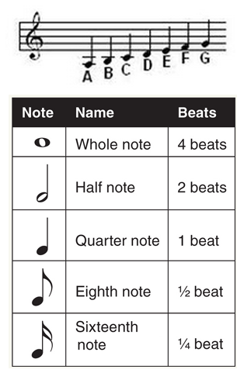
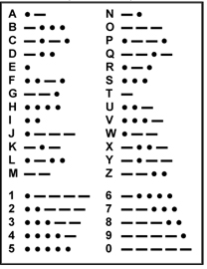

Figure 5: Morse Code for representing symbols by means of dots, dashes, and spaces, which can be transmitted as mechanical or electromagnetic pulses of varied lengths
Figure 6: Names of musical notes and durations

The natural, spontaneous development of languages should not be interrupted – there is much to learn from this evolution. Yet the modifications and improvements within the controlled language nomenclature – the scientific language – should be considered. A false notion might initially appear that, by introducing newly constructed terms, we only emphasize the problem of the voluminousness of the knowledge. On the contrary, in the context of the actual increase in knowledge, appropriate introduction of new principal terms can help to promote more rapid storing, sharing, using and creation of knowledge.

From the distant 19th Century, the words of Rudolph Clausius come to us as an inspiration, an example how this kind of problems can be dealt with: "I propose… to cal S the entropy of a body, after the Greek word ‘transformation’. I have designedly coined the word ‘entropy’ to be similar to energy, for these two quantities are analogous… that an analogy of denomination seems to be helpful" [4]. Helpful for what, if not − helpful for the transfer of knowledge? Another example of coining new terms is equally spectacular. In late 20th century, Richard Dawkins invented new word “meme” to refer to any cultural phenomenon that can be classified as a replicator of ideas and behaviour, such as fashion, attitude, style, writing, speech, etc. The similarity with the concept of “gene” is intentional. Memes replicate by means of exposure to humans, who are copiers of behaviour and information. Since humans do not necessarily copy memes perfectly, various refined, combined or degenerated mutations are generated. Cultural evolution occurs in analogy to the selection of genes in evolution. Constructive memes are getting themselves copied, they spread and continue in mutations, whereas the degenerative memes have a higher probability of being ignored and forgotten. Meme transmission does not necessarily require involvement of known mater media in a way the genes are exposed, i.e. a painting style can be inspired by a custom of observing the cloudy sky and enjoying in the sunset produced colour spectra.

It can be argued that the contemporary state of scientific nomenclature presents one of decisive advances in language constructs. The scientific and educational practice is seething with useful examples of enlightening the same phenomenon, concept or even theory by means of differing (but not contradicting) views and explanations. A number of experiments with combining the knowledge presentations with various forms of art have proven to be successful as well.

However, the current practice of mutating the principal terms used to designate the overarching concepts can lead to curious labyrinths. The fundamental terms which comprise in one word the depth and breadth of embraced ideas and theories should not be associated with man-made ambiguity. There are quite a number of works pointing to the problems related to the ambiguities in scientific, educational and engineering publications [5]. The particular word applied to the thing is important because the word can influence our perception of the thing through the powerful symbolic and psychological effects. Connotation and association trigger certain almost automatic responses within our brains, and create attitudes toward, and influence our judgement about, the thing being described by the word merely because that particular word has been used [6].

The above overview shows that humans worked towards developing practical, universal and clear techniques of recording and sharing knowledge. Historically, development of words and corresponding recording modes has undergone a range of forms in response to the needs of evolving society. In this age of knowledge, it appears that there is a critical need to compact the whole concepts by means of transparent unambiguous unique words – fundamental scientific terms.

The significance of an additional aspect of establishing the scientific terms has surfaced with the expansion of the information processing devices (computers). ‘Data mining’, ‘information retrieval’, ‘search tools’ and similar facilities would require quite differing and certainly more complicated support if they would not be based on the word – term – searching models.

Importance of terms should not be confused with the usefulness of diverse methods available for describing the concepts represented by these terms. Nowadays presenting, modelling and animation techniques allow for explaining the same concept using differing points of view and diverse modes of presentation. This diversity in interpretations is very useful, however, it must not be confused with the requirement for invariability in the definition of the concept itself.

Knowledge

Preamble

In our eternal and infinite surroundings, our fate depends on our knowledge. Notion of knowledge is discussed by numerous sciences such as Ontology, Gnoseology, Epistemology, Sociology, Psychology, and treated within the fields such as Philosophy, Logics, Didactics, Cybernetics, Semantics and Informatics, see Figure 7. Fundamental categorisations are derived within each discipline and ideally a consensus with regard to concepts such as ‘definition’, ‘knowledge’ and ‘information’ is expected to emerge on the grounds of such broad treatment. However, no such consensus has been established in academe or beyond, yet.
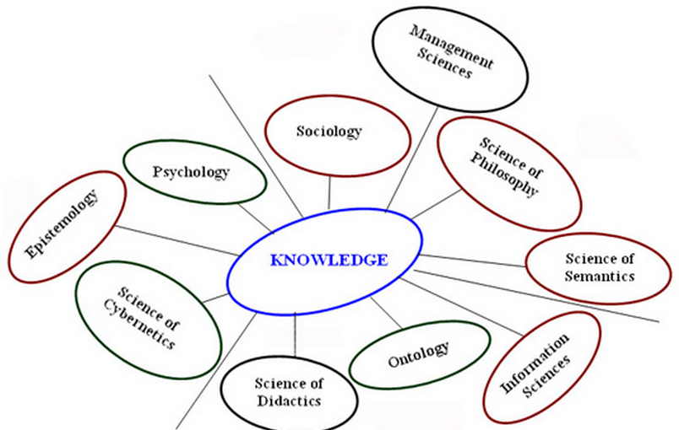

Figure 7: Academic disciplines concerned with the fundamental concepts of knowledge

Our knowledge has undergone a long history of evolution and we indeed continue with collating the further knowledge about our Globe, setting our sights at the outer space as well; at this stage we are aware of over 100 billion galaxies and each galaxy contains up to 400 billion stars. We are exploring the planets orbiting our own star ─ the Sun, and the electrons orbiting the atomic nuclei. The corresponding knowledge repositories grow exponentially and the question is how to store, share, manage, combine and use this immense treasure.

Mankind’s knowledge is transferred from an individual to his contemporaries, from generation to generation and from civilisation to civilisation for at least several thousand years. But the history of the Man stretches much further back and there is a solid evidence of tools made well over a million years ago. A ‘tool’ is a phenomenon that significantly increases the probability of realisation of an intended (premeditated) change, providing that relevant definitions are used. Since a ‘definition’ is a substantial component, a ‘brick’ necessary to construct and communicate the subject of knowledge, one could hypothesise that the first traces of knowledge are well over a million years old.

It is important to distinguish the concept of “knowledge” from the concept of a “process of understanding”.
The process of understanding involves noting something that is partly or completely unknown, observing or anticipating certain phenomenon at an instant when a sufficient relevant knowledge does not exist, or the observer(s) is (are) not aware of the existence of such knowledge. However, during the process of understanding, the relevant knowledge is being created or retrieved (to some extent, at least).

The concept of “knowledge” will be defined below.
Classification of Knowledge

Knowledge developments and records can be combined to have a central focus and to converge to similar classes of concepts following a hierarchy that serves to establishing a (scientific) discipline. The major motive for grouping theories and hypotheses into the scientific disciplines is to facilitate the storage, growth, communication and application of a specific category of knowledge.

The academic educational streams (scholarly disciplines) are established with an additional motive to enable systematic learning, study and further extending the observed class of knowledge. There are numerous classifications of disciplines used in academe and beyond; Figures 8 to 12 present some examples of possible groupings.
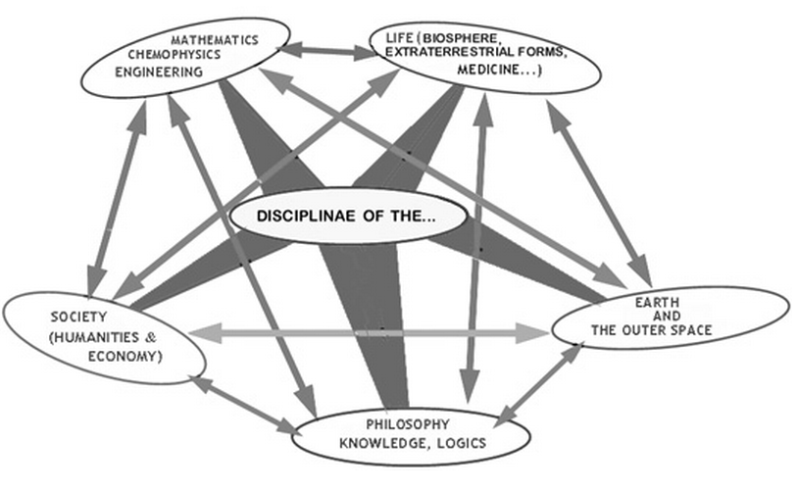

Figure 8: An example of possible grouping of disciplinas
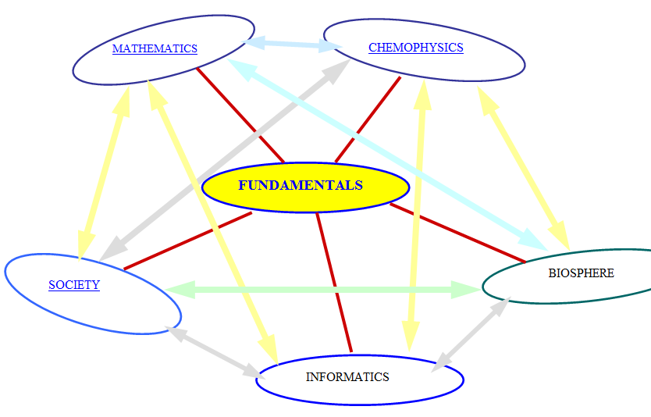

Figure 9: Another example of possible grouping of existing knowledge

Note that in Figure 9, a phrase ‘existing knowledge’ is used. The antonym for the term 'knowledge' is not 'ignorance'. 'Ignorance' is a lack of education, unfamiliarity with otherwise existing knowledge. The opposite of knowledge is an infinitely large, unexplored, undiscovered, unanticipated variety of relations, processes and something else within and beyond us.
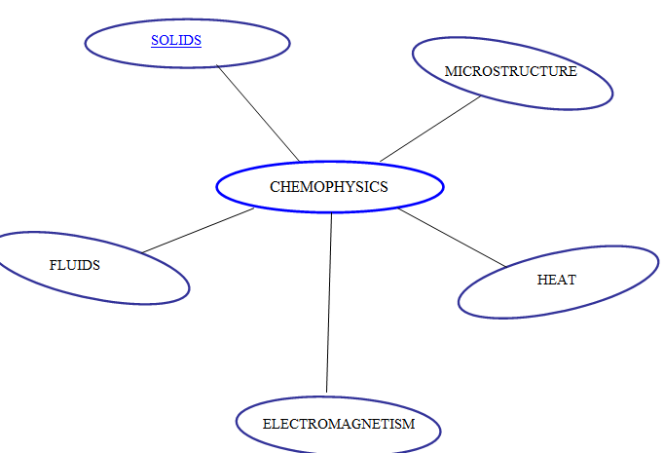

Figure 10: An example of possible sub-classification of the domain of chemophysics

Term ‘chemophysics’ is coined to point at overlapping in the disciplinas of ‘physics’ and ‘chemistry’.

"The scholars of ancient Greece were amongst the first we know of to attempt a thoroughgoing investigation of the universe − a systematic gathering of knowledge through the activity of human reason alone. Those who attempted this rationalistic search for understanding, without calling in the aid of intuition, inspiration, revelation, or other non rational sources of information, were the philosophers (from Greek meaning ‘lovers of wisdom’).

Philosophy could turn within, seeking an understanding of human behaviour, of ethics and morality, of motivation, and responses. Or it might turn outside to an investigation of the universe beyond the intangible wall of the mind − an investigation, in short of nature.

Those philosophers who turned toward the second alternative were the natural philosophers, and for many centuries after the palmy days of the Greeks the study of the phenomena of nature continued to be called natural philosophy. The modern word that is used in its place − science, from a Latin word meaning ‘to know’ did not come into use until well into the 19th century. Even today the highest university degree given for achievement in the sciences is generally that of ‘Doctor of Philosophy’.

The word ‘natural’ is of Latin derivation, so the term ‘natural philosophy’ stems half from the Latin and half from the Greek a combination usually frowned on by purists. The Greek word for natural is ‘physikos’, so one might more precisely speak of ‘physical philosophy’ to describe what we now call ‘science’. The term physics, therefore, is a brief form of physical philosophy or natural philosophy and, in its original meaning, included all of science.

However, as the field of science broadened and deepened and as the information gathered grew more voluminous, natural philosophers had to specialize, taking one segment or another of the scientific endeavour as their chosen field of work. The specialties received names of their own and were often subtracted from the once universal domain of physics.

Thus, the study of the abstract relations of form and number became the science of mathematics; the study of the physical nature of the earth we live on became geology; the study of the structure, function, and relations of living organisms became biology, and so on. The term physics then came to be used to describe the study of those portions of nature that remained after the above-mentioned specialties were subtracted. For that reason the word has come to cover a rather heterogeneous field and is not as easy to define as it might be. What has been left over includes such phenomena as motion, heat, light, sound, electromagnetism…" [10 - 12]

Historically, modern chemistry evolved out of ‘natural philosophy’ and to a significant extent, out of alchemy following the chemical revolution (1770’s).

Today the major difference between chemistry and physics is in that science of chemistry departs from the phenomena observed at the scale of molecules and atoms. A basic building block of chemistry is an atom. Science of chemistry builds the knowledge starting from this magnification, in both directions, i.e. towards the larger scales, and towards the smaller dimensions. However, in chemistry, there is an apparent tendency to advance “faster” (i.e. to a more voluminous and comprehensive extent) towards the smaller magnifications.

Physics, on the other side, did not base its departing point at any scale. Rather, it builds its knowledge structure based on generic questions such as what kind of motion phenomena can be understood when observing planets or electrons, light or any other form of radiation, propagation or vibration at any scale.

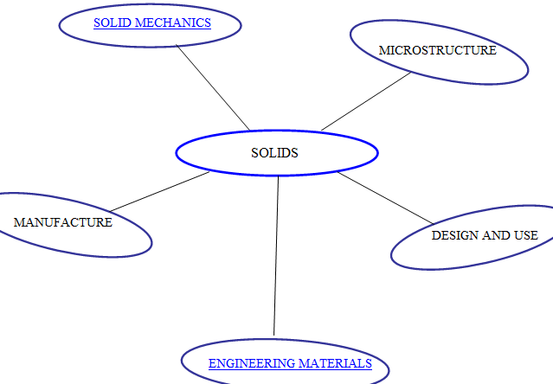

Figure 11: One way of classifying our knowledge about ‘solids’

The idea of ‘solids’ is arguably a historical consequence of our neurobiological capability of perception and sensing the difference in matter attributes termed broadly as solids, liquids and gases.

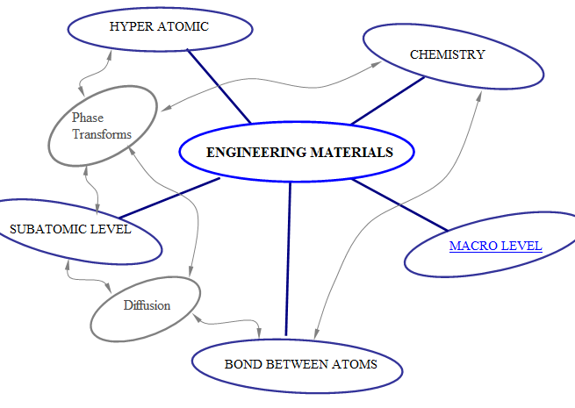

Figure 12: One way of classifying our knowledge about ‘engineering materials’

Both deduction and induction, which seem to be inwrought modes of understanding, require us to refer to specific problems and cases of knowledge application. Apart from prediction and explanation of processes that occur beyond our control (natural phenomena), the most prominent demonstration of the validity of our knowledge is the creation of new artefacts. The attributes of these manmade products are largely pre-defined, and their successful realisation is a statistical function of pertinent knowledge. A single realisation in itself does not present significant verification of applied knowledge. However, multiple realisations, such as those achieved in an industrial manufacturing process, provide statistically significant evidence about the knowledge validity. In addition, these replications provide useful ground for generating prospective hypotheses. Manufacturing processes are a good category where relevant examples can be sought and exposed to both inductive and deductive study. The case studies from manufacturing industry can be used to monitor, validate, disseminate and further improve our knowledge about the actualised and controlled processes. In the light of contemplations about the growth, validity and nature of knowledge it is educative to view some excerpts from the history of technology which addresses at large various stages of manufacturing developments.

What is knowledge?

The above partition of our knowledge classification has been thus far following merely the streams of materials. So called material science has historically been concerned with generating the variety of non-biological forms in solid state. However, the recent discovery of biomaterials, foames, nanomaterials, plasmonics and similar configurations requires extending the knowledge base.

In the actual application of knowledge e.g. in industry, sport and other spheres organised to manage our needs and interests, we often combine canons, theories and hypotheses taken as convenient from the quite differing scientific disciplines. We create so called cross-disciplinary constructions of knowledge. Theories that have been validated in one discipline can help in resolving issues that are traditionally investigated within a completely different area. A canon is a part of knowledge accepted as representing a field (domain).

A question is whether the existing, authoritatively established academic disciplines present the only possible arrangement of the repositories of the existing knowledge? Did these disciplines become the cages that obstruct efficient combining of available theories and hypotheses?

Recent advances in artificial intelligence and long term contemplations in cognitive sciences have brought attention to the idea that our existing knowledge is largely anthropic. A historical ontology and some nowadays philosophical contemplations [13] point at the importance of concerns such as what are the actual attributes of what we call the universe. The ‘universe’ here stands for ‘everything’, and the ontology is in fact based on an axiom that ‘the universe exists, and there is something within that universe’. Some philosophers went even further by postulating that the universe exists, indeed, it is incessant and completely occupied by an endless variety of continuously mutating forms. Ancient pantha rei is reappearing at scales that range from infinitesimally small to infinitely large. Matter forms always change but never vanish. Are we hopelessly lost in an infinite and eternal space, or are we endlessly rich because of the limitless resources around us? It appears that this depends on our capability to discover, understand, record, share and apply the knowledge. But what exactly this concept of ‘knowledge’ means? What is the meaning of ‘meaning’ [7, 8] ?

It is significant to note at this point that some phenomena (including man-made systems, for example a theory, a chemophysical system, etc) can be brought in conditions that resist to this restless environment, at least to some extent. In the case of man-made systems, this ‘constancy’ is sustained by activating various man-made (man-initiated) processes. Consider the following three examples: first one is a manufacturing process where the sophisticated control and maintenance sustain the process within the predefined tolerances. Some products such as the bread or the dishes have been produced for over two millennia. Second example is the international prototype kilogram stored in an environmentally monitored safe. Third example is a definition (a “law”, a “rule”) that was well presented and verified in several disciplines and in many practical applications. Some definitions have resisted to changes for more than two millennia, for example the Rule of Pythagoras, and it is anticipated that this (and a number of other definitions) will continue to exist unchanged. In each case a significant knowledge is involved in order to enhance constancy.

Knowledge is defined in the Oxford English Dictionary as (i) expertise, and skills acquired by a person through experience or education; the theoretical or practical understanding of a subject, (ii) what is known in a particular field or in total; facts and information or (iii) awareness or familiarity gained by experience of a fact or situation. Philosophical debates in general start with Plato's formulation of knowledge as "justified true belief". There is thus no single agreed definition of knowledge presently, and there remain numerous competing theories. [14]

Knowledge acquisition involves complex cognitive processes: perception, learning, communication, association and reasoning. The term knowledge is also used to mean the confident understanding of a subject with the ability to use it for a specific purpose if appropriate. [14]

It is important to note the difference between the concepts of ‘noema’ and ‘knowledge’. A single person can make assumptions and study information, definitions, hypotheses and even a significant combination of several theories. By the process termed ‘noesis’ a single person arrives in his mind to ‘noema’ about anything. ‘Noema’ is a special case of, somewhat relative knowledge achieved at the specific point in time by a single person. Without the noesis, consciousness would be unconscious (conscious of nothing). ‘Noema’ is used in medicine and epistemology to denote the state of the (part of the) mind of a single person, which is the result of person's intention to understand something, and consequently brings about her/his belief about relevant, perceived understanding. Difference between ‘noema’ and ‘thought’ is in that the ‘thought’ is not necessarily intended nor believed by the thinker. (Strictly speaking, Oxford English Dictionary quotes usage such as "'noema’ is obscure speech or speech that only yields meaning upon detailed reflection.”, referred to source Peacham (1577) “Garden of Eloquence”. It is proposed herewith to abandon this definition, (i.e. noema = obscure speech), as an obsolete version. [15].

Misconceptions such as one “Knowledge cannot, as such, be stored in computers; it can only be stored in the human brain. … There is no knowledge without someone knowing it.”; [16], p 11) can certainly be avoided if this statement is rephrased as follows: “Noema cannot, as such, be stored in computers; it can only be stored in the human brain; there is no noema without someone contemplating it.”
On the other hand, knowledge is established as a system of relations shared by more than one person, usually a significant number of humans. Knowledge can continue to exist over huge time-span with a considerable reliability. At a higher level, knowledge is stored systematically as an asset within the scientific disciplines and it is accessed and used for multiple purposes by an individual, by a group and by the broadest society.

An individual person can reach high-level noemas, and this state could be maintained over a significant, yet finite period of time. However, the synergy achieved by transforming noemas into shared knowledge offers incomparably larger potentials. In order to take the highest degree of advantages of the available knowledge the group must organise, share and communicate the relevant knowledge at an appropriate level. The level at which the relevant knowledge is structured, presented (explained), stored, communicated, compared and shared determines its eventual usefulness.

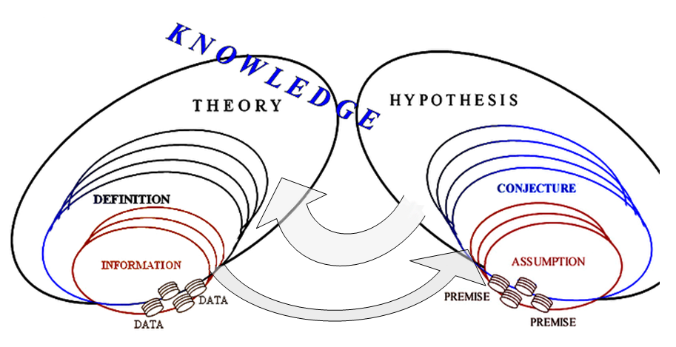
We propose the following definition: Knowledge is an infinitely replicable intensifier for the probability of anticipated realisation; its components can remain unalterable, however they also can vanish (disappear).

Figure 13: Knowledge structure

The above vision allows for decomposing knowledge into elements and analysing its more simple constituents.

Data and information

It is clear that what we reached as an understanding of certain phenomenon does not necessarily reflect all, or even the most significant aspects of that phenomenon. By ‘significant aspects’ we mean these knowing of which significantly affects the realisation anticipated by means of that knowledge. It must be remembered that beyond our knowledge there is an infinitely large, deep and broad, unexplored, undiscovered, unanticipated variety of relations, processes and something else within and beyond us. Inasmuch our neurophysiology provides us with the criteria about the usefulness and correctness of knowledge, our understanding of the actual and more complete relations might be obstructed due to the antrophic bias.

The first approximation to knowledge is based on data and information inferred from these data. Typical examples of data are measurements such as mass, length and time. Over the centuries, a practical approach to the material objects was developed by measuring their attributes such as mass, dimensions and position at an instant of concern. More detailed insight into the object structure led to describing the structural constituents by their own mass and dimensions, including their position within the overall volume of the global body. By measuring the change in position with time, concepts such as velocity and acceleration were developed. And, by multiplying mass with acceleration a concept of force emerged followed by the idea of energy.

Data present a first relation established intentionally in order to understand something. A collection of data is an outcome of observations, measurements or otherwise activity that results in a set of recorded representatives, models, of some aspect or attribute of a process, object or other phenomenon. More detailed account about the data is available elsewhere [22]; below are outlined several features. Data consists of variables, and the Figure 14 shows one example of variable classification.
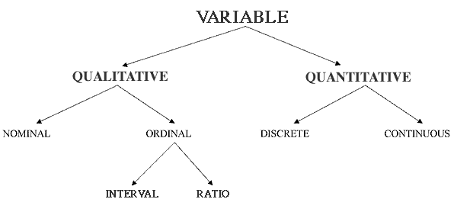

Figure 14: An example of data classification

A typical style of presenting or displaying a set of data is through table type structures comprised of rows and columns. In such tables, the columns of generally signify attributes or members of observed set and the rows (tuple) signify observations belonging to one single attribute or member.

The explosion in the development of methods for analyzing categorical data that began in the 20th century has continued with an increasing pace. Contemporary advances in the data and information processors have enabled real time analysis of most challenging phenomena such as DNA code and the structure of the universe.

Some information can be grasped by sheer look at the data presented by means of descriptive statistics, however, the concept of information entails a significantly higher levels of understanding of something as opposed to the data collection.

Information is an infinitely replicable intensifier for the probability of anticipated realisation. In the strict sense promoted in this publication, information is unalterable, however it also can vanish (disappear). It will be shown that the similar definition is proposed for the concepts of ‘definition’, ‘theory’ and ‘knowledge’. The principal difference between these concepts is in the degree of abstraction, degree of probability intensifying and the quantity of incorporated logical relations.
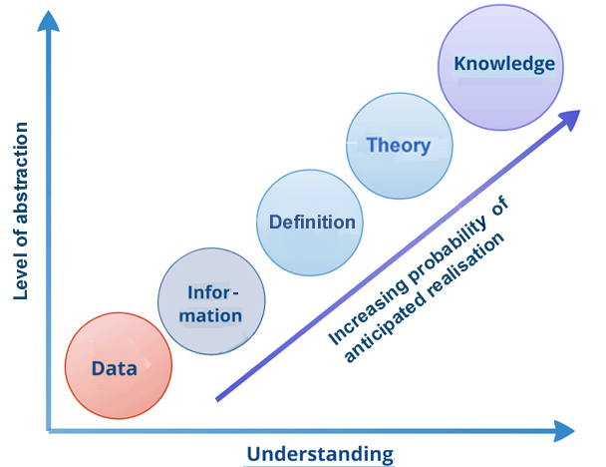

Figure 15: Knowledge scale

Definition

The minimum intent

The minimum intent of the following definition of term ‘definition’ is to present a reference (metric, comparator, norm) that must be observed when defining scientific and engineering concepts.

Axioms

Axioms are initial assumptions. It is impossible to analyse anything without adopting several non contradicting points ─ axioms. Axiom is a proposition that is not susceptible of proof or disproof; its truth is assumed to be self-evident on its own merit. However, axioms can be changed, and replaced if this is done consistently for the whole derived analysis.

It is useful to start with a quite general concept—‘something’—which can mean anything (but it does not automatically include ‘everything’). ‘Universe’ embraces everything in its uttermost totality.
The concept of ‘ambient’ is used for everything in the vicinity of, and, to a certain degree within, something. ‘Ambient’ is a fraction of the ‘universe’.
‘Process’ refers to something that can be distinguished from its ambient. When the rates of changes are significantly differing in one process relative to the other, the ‘slow’ process is frequently termed ‘event’.
‘Relation’ involves two or more processes (events), and ‘system’ is something constituted by two or more relations.
‘Phenomenon’ is a generic concept (hypernym) for the above terms, providing that at least one human sense indicates (directly or indirectly) its existence. This leaves open a possibility that in our ambient may exist something we did not observe (detect, sense) thus far. Our ambient is constituted of phenomena and other processes, relations and systems.

It is assumed that all definienses used in this treatise are already intrinsically known. It is also assumed that definienses are not homonymous nor synonymous, nor do they contradict each other.

Definition
‘Definition’ is a fixed (posited) set of relations that significantly increase the probability P of an intended (planned), realised (observed) or anticipated event. Planned events are to be actualised by a system (not necessarily manned) that can be organised to utilise a definition for such a specified purpose. Realised (observed) events are a matter of past, and they may or may not occur again. A definition may be used to prevent anticipated events that are deemed to be undesirable.

When an event affects some phenomena, the probability P can be estimated quantitatively, in addition to derivation of other quantitative measures such as entropy. A definition cannot be generated (created) without the existence of a manned system (e.g. a department within a socio-economic institution) which is organised and structured above a certain level of chaos. However, once it is generated and recorded, a definition can continue to exist (to be recorded, stored) without the existence of the initial manned system. When conceived by a relevant system, a definition becomes autonomous from its own representation (imprint, record); definition can be distinguished from any substance of which its record is made. Therefore, an identical definition can be replicated endlessly; it is infinitely shareable. A definition is unalterable, however, it is terminable, i.e. the relevant records can be destroyed, a definition forgotten, etc.

It appears that, if the probability P ≈ 0.5, the relevant concept can be deemed to be ambiguous, while with P converging to zero it seems only logical to doubt the validity of its definition. As the value of P approaches 1 (one) the validity of definition increases. Numerous deterministic concepts assume a maximum value of P, e.g. the probability of
a + b = b + a

is P = 1, for all numbers known thus far.

Reliable definitions (with P significantly higher than 0.5) can be used to derive new hypotheses by means of logical deductions and inductions. By subsequent collating significant evidence, so formed hypotheses can be converted into new definitions.
Definition is composed of inter-related components: information and data. The attribute ‘fixed’ (‘posited’) in the above context emphasizes the difference between the restless process and the permanent information. In other words, although our ambient is in the state of perpetual motion, a definition—a model—can be generated, not to imply that the defined phenomenon is at a standstill, but to create a specific unchanging metric (index); unchanging until useless. Existing definitions can be used to deduce new definitions.

Phenomena change in an endless succession of forms in various manners at very differing rates (‘speeds’). These differences range at the galactic proportions. In terms of a definition, this that can be perceived as continuous or incremental processes, ranging from quantum leaps to comparably momentous discrete phenomena. Collating informations and data can be perceived as relatively continuous process of making ‘snap shots’ (instantaneous records), while establishing a definition is a radical final stage in this nucleation. It is important to comprehend that the ‘definition’ is a static, unchanging relation ─ a theoretical (abstract) reference (an index point). Depending on the rate of the observed phenomenon, information can be perceived to be related to an ‘event’ or a ‘process’. An event can be viewed as an identifiable stage of some process; usually the rate of change of such stage is considerably lower compared to the rate of changes of other relevant processes. Similar contemplation can be made at the higher level: a theory or a hypothesis, both are the resulting stages ─ systems that constitute a final construct. Establishment of a theory and a hypothesis is marked by an evident transformation from one to another level of knowledge.

One way of comprehending the above ideas is to visualise the following analogy: an information is an ‘intellectual photograph’ of a phenomenon. Following this illustration, a definition can be depicted as a photo album, while the theory can be compared to the whole library of photo albums. The whole comparison can be extended to ‘movie clips’ (animation records) where the entire dynamic sequence of a process is recorded and it can be replayed for many viewers.

Any theory and any definition are limited by their assumptions and the scope of applicability. Although many hypotheses can be derived from a well established theory, reality is that there will always be possible to extend explorations and make further contributions to knowledge. In addition, many hypotheses have been proven erroneous, and numerous theories and definitions had to be modified if not abandoned. This process would be impossible if an incremental evidence of concepts is not established with fixed definitions that serve as a reference for further development.

A definition should be complemented with a ‘statement of minimum intent’ which specifies a minimum domain of purposes for which this definition can be used. This statement does not exclude a possibility of using the same definition correctly for some other purposes. However, any extended use must not violate (contradict) already-established meanings. This includes the need to eliminate homonymy as well, because the reasoning modality is influenced adversely by perceptions of similarity, which can be blunted by conceptual inconsistencies). In addition, a definition must be complemented with axioms, with one or more examples, and, when needed and possible, with audio-visual presentations. Multimedia are ideal tools for illuminating complex concepts. It is worth noting that the information media can be mutually translated, i.e. visual information can be translated into information received by tactile, hearing and other senses.

A definition should also include both hypernym(s) and hyponym(s). Including holonym(s), meronym(s), antonym(s), etc is recommended, but may be omitted when it causes prolixity.

Let us present an example of a ‘definition’ (the axioms are identical to the above listed axioms). A ‘tool’ is a phenomenon that significantly increases the probability of realisation of an intended (premeditated) change, providing that relevant definitions are used; e.g. a hammer, a pen, etc. An example of using a tool is the use of a hammer to make a wooden fence. A hypernym for a ‘tool’ is a ‘resource’. An example of a hyponym is ‘dishware’; the holonym is ‘equipment’. An example of a meronym is ‘tool handle’, and examples of antonyms are ‘garbage’ and ‘obstacle’.

Figure 16: A hammer

The difference between ‘definition’ and ‘tool’ is in that a definition can be used without a tool, while a tool cannot be used (in a sense in which its use was anticipated) without a definition. Furthermore, absolutely identical definitions can be endlessly multiplied and used simultaneously at differing locations, while any two arbitrary tools differ at least for some amount of tolerances.

Definitions are necessary components needed to construct and communicate the subject of knowledge. A definition is built by means of its structural elements: pieces of information. Information and data are built by virtue of construction bits, signals of various kinds. These signals are combined in various manners; one of most frequently used combinations includes the ‘terms’.

It is hereby recommended to avoid using the term ‘definition’ to denote the following concept: The fidelity (accuracy) with which detail is reproduced by a television or video display system ranging from fuzzy to sharp appearance (also called ‘resolution’). [23]

When addressing the accuracy (fidelity, resolution) with which an electronic system reproduces the image based on its input signal (sharpness of an image as seen by the visibility of detail, clarity of outline), in computer science appears the need for introducing the term for “the number of pixels per square inch on a computer-generated display (the greater the number of pixels, the clearer the picture)”. Reputable sources such as Elsevier Inc. distribute scientific publications (e.g. [24]) where the above concept is denoted by terms such as ‘high-definition television’, ‘standard definition’ etc. This practice is however misleading since it implies that the ‘high-definition’ device (screen) provides automatically more knowledge than a ‘standard definition’ screen. However this is not the case. Firstly, the screen may display a completely false information, and in such a case the sharper display delivers most likely the more confusing picture. Secondly, in many cases the resolution of knowledge record does not affect the substance of actual theory conveyed. For example sharpness of the font used to present some alphanumeric paragraph is useful only to a certain degree; increasing the resolution beyond that threshold does not help in improving the actual content. Therefore the concept of ‘definition’ is too high a category and it should not be used to denote the ‘resolution’ (‘sharpness’, ‘clarity’, ‘fidelity’) of a computer monitor, television screen or a display generated by some other electronic device.

Other sources [24, 25] allocate to term ‘definition’ a whole range of interpretations. In some cases, such as ‘dictionary definitions’ [25] the significance of the function (purpose, intent) of definition is indicated. In other cases (such as ‘recursive definitions’ and ‘genetic definition’) sources [26 and 27] address variety of issues such the development history and method of defining, but fail to point at the significance of the relation between the ‘minimum intent’ of the definition and its content. Concept of definition proposed in this treatise is applicable to each of the cases listed in sources such as [26 and 27], and therefore presents a hypernym for this variety.

For special “type” ─ ‘stipulative definition’ ─ sources [26 and 27] suggest that “A stipulative definition of a term carries a meaning which a speaker wants it to convey for the purpose of his or her discourse. Thus, the term may be new, or a stipulative definition may prescribe a new meaning to a term which is already in use.” Allocating new meaning to already existing term is bad practice which leads to unnecessary homonymy. It is more appropriate to coin new term for each new meaning.

Theory, Hypothesis and Knowledge

A system of inter-related definitions constitutes a theory.

In addition, an assumption that our ambient comprises something yet to be defined, and/or is difficult to be detected by our senses, allows for generating unlimited number of further assumptions. As long as they do not contradict themselves, they can be combined to create hypotheses. Assumptions and hypotheses are important, because they present initial approximations needed for generating new definitions and theories. A complementary way of generating theories is by defining phenomena observed in our ambient.

In this presented transcript, it is proposed that the knowledge is a construct formed by interlinking a spectrum of intellectual components, the simplest entities being termed ‘information’. Information is composed of yet a simpler form, termed ‘data’. ‘Data’ (which can be further decomposed into ‘signals’) are tentatively positioned at the boundary of knowledge entities. There is a broad variety of levels expanding between the information layer and the highest strata of knowledge; several convenient concepts across this span are introduced as ‘assumption’, ‘definition’, ‘hypothesis’, ‘theory’, ‘canon’ and ‘disciplinae’. ‘Disciplinae’ is here defined as a subset of knowledge ─ a scientific or other knowledge encompassing a domain (an area, a field) of knowledge that is for some reason distinguishable from other knowledge.

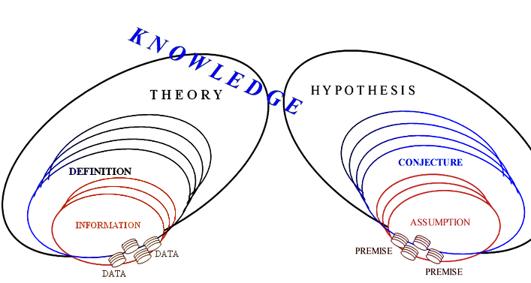
Knowledge is an infinitely replicable intensifier for the probability of anticipated realisation; its components can remain unalterable, however they also can vanish (disappear). Knowledge components are conceptualised in figure 17.

Figure 17: Knowledge components

As another example, an information that a simple mechanical lever is made of a carbon steel comprises data such as chemical content of that steel (e.g. 0.2 % C, 0.5 % Mn, 0.8 % Si etc) and lever dimensions. Such information contributes to constituting a definition only when the mechanical principles of lever operation are explained along with giving an example of application. Furthermore, through combining this definition with other related definitions, such as moment of force, a theory of simple mechanisms (machines) is constructed. By amalgamating and broadening this theory with the complementary hypotheses and theories such as elasticity, statics or dynamics this system grows into branch called mechanics of solids which is related along with other branches to the more general disciplinae of mechanics.

“A ‘hypothesis’ is a tentative insight into the natural world; a concept that is not yet verified but that if true would explain certain facts or phenomena (a scientific hypothesis that survives experimental testing becomes a scientific theory)” [28]. For example we know many facts about the electromagnetic force, but at this stage we can only hypothesise about the remaining details as to why there is an attraction force between an electron and a proton.

A canon is constituted by a system of inter-related theories and hypotheses. They can be combined as to have a central focus and to converge to similar classes of concepts following a hierarchy that serves to establishing a (scientific) disciplinae. Major motive for grouping theories and hypotheses into the scientific disciplines is to facilitate storing, growth, communication and application of specific category of knowledge. A disciplinae is a specialized structure of knowledge constructed by combining canons embracing pertinent theories and hypotheses which together constitute the informational content of a systematic endeavour to explain (some part of) the universe.

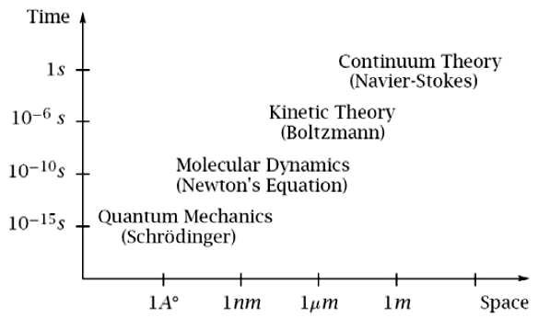
In the current terms, knowledge and many of its concepts are discretized. Some of theories are applicable at the macroscale phenomena but not at the nanoscale world. For example the concepts of temperature and pressure are meaningless for processes (phenomena such as sub-atomic particles) that exist at the lengths of order of magnitude below 10⁻¹⁰ m. Figure 18 below presents several examples of applicability of theories at differing scales:

Figure 18: Different space-time scales [32]

How the actual environment looks like in the vicinity of an arbitrary point? A popular frame of reference is schematically presented in Figure 19.
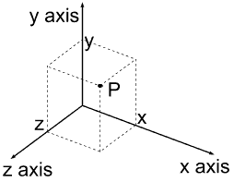

Figure 19: The time-space system

In this system, the position of a point P is defined with a reference to origin (x = y = z = 0) and the coordinates x_{P}, y_{P} and z_{P}. With adding the fourth coordinate – time – it is possible to describe motion of the point P in terms of four dimensions.

If we assign to the chemophysical concepts such as length, time, mass etc the meaning of dimensions, we can present our cognition of realm as illustrated in Figure 20 below [13].

Figure 20: n-dimensional representation of the
domain around an arbitrary point [13]

In the above Figure 20 the length is represented by one dimension only with the meaning that corresponds to the order of magnitude of the observed phenomenon. Time and any other dimensions (units) are also represented by one dimension each; that dimension is represented by one ordinate in each case. This can be schematised with a simple concept of an n-dimesional sphere, a cross-section of which is shown in the above figure 20.

Epilogue

The antonym for the term 'knowledge' is not ‘ignorance’. 'Ignorance' is a lack of education, unfamiliarity with otherwise existing knowledge. The opposite of knowledge is an infinitely large, unexplored, undiscovered, unanticipated variety of relations, processes and something else within and beyond us.

Our evolutionary sensory experience directed the mental models that underpinned our early knowledge. This intimacy with and increasing variety of “objects”, “bodies” and other phenomena, impelled us to adopt partly instinctive and partly conscious economy of mental designation, which was mirrored in our thoughts, speech and knowledge records.

The attempts to translate the knowledge models developed with regard to macro-world into their analogues that should reflect our increasing insight into the micro-cosmos are being defeated. The concepts of mass, pressure, force, temperature and so on, are not suitable once we reach below the levels of molecules. The similar effects, met when observing the phenomena at the galactic scales, prompt for considering scale determiners, the size factors that delimit the scope of the concept applicability.

Apart from the direct logical relations, deductions and derivations (such as mathematical equations), the appropriate way of establishing validity of assumptions, conjectures and hypotheses is by means of statistical analyses. Statistical methods allow for estimating the probability that an application of particular knowledge and its components will result in correct understandings, anticipations and realisations.

Some people associate with the concept of “knowledge” human states such as belief, tendency, and emotions. The ideas formulated in ethics and aesthetics such as the perceptions of justice, beauty and it’s opposites are the important subjects in philosophy as well.

Relations of ethics and knowledge are discussed by a number of authors [48]. A belief that the overall efficiency, growth and verifiability of knowledge increase dramatically with the sheer quantity of informed participants is fundamentally constructive. Furthermore, a belief that the open and rapid sharing of existing knowledge across the trans-disciplinary boundaries incubates nucleation of new ideas, increases the probability of making viable hypotheses and speeds up the testing procedures, leads to significantly better utilisation of resources and to more rapid progress. A constructive competition is most effectively achieved by: (1) investing resources and energy through the cross-disciplinary sharing of knowledge; and (2) publishing new knowledge or providing improved evidence for validation of existing knowledge through its applications.

Many would agree that acting in a harmful manner, such as hiding the truth, or otherwise not sharing knowledge, and denying the education is unethical and even unlawfull. Although beauty in things exists merely in the mind which contemplates them and cannot be explained logically, many would agree that our existence is significantly affected by aesthetics, and also, that undermining the common knowledge is fundamentally anaesthetic.

The significance of knowledge extends beyond any single discipline, regional language and local culture. This significance stems from appreciation of the actual size and depth of our environment (beyond the universe and below the nano-strata) and due to the global implications on scales beyond and above the short-ranged interdependences.

References

[1] Cave wall drawings from the Chauvet Cave. (2000). French Ministry of Culture and Communication; Regional Direction for Cultural Affairs - Rhône-Alpes region; Regional department of archaeology. Retrieved August 1, 2000 from http://www.culture.fr/culture/arcnat/chauvet/en/album.htm

[2] Language. Encyclopædia Britannica from Encyclopædia Britannica Premium Service. Retrieved December, 2, 2003 from http://www.britannica.com/eb/article?eu=114866

[3] Ong, W. J. (1982). Orality and literacy: The technologizing of the word. London: Methuen.

[4] Serway, R. A. (1996). Physics for scientists & engineers with modern physics. Philadelphia: Saunders College Publishing.

[5] Spuzic, S. (2011). Bibliography of works pointing at ambiguities in scientific, educational and engineering publications. Retrieved December 17, 2011, from http://db.tt/TBMSuB7

[6] Robert Harris (2010) “Semantics 1” www.virtualsalt.com/think/semant1.htm accessed 24 December 2012

[7] Griffen, E.M.(1997). A first look at communication theory. New York: McGraw-Hill Companies Inc.

[8] Ogden, C.K.(1923). The meaning of meaning. New York: Harcourt, Brace & World, Inc.

[9] “List of writing systems” Wikipedia, Wikimedia Foundation, Inc. Accessed on 22 December 2012 http://en.wikipedia.org/wiki/List_of_writing_systems

[10] group of authors “Physics Phenomena ‘Physics is Fun’ Feimer's Physics Page” 3M&D inc. http://www.physicsphenomena.com/
http://www.physicsphenomena.com/TopicsofPhysics.htm (accessed 18th June 2009)

[11] Isaac Asimov "Understanding Physics" (a book) Three Volumes in One, by Barnes and Noble (copyright 1966 by Isaac Asimov) last edition published in 1993

[12] BBC Bitesize Science: Chemistry
http://www.bbc.co.uk/schools/ks3bitesize/science/chemistry/elements_com_mix_intro.shtml (accessed 18th June 2009)

[13] Selam Spuzic “Philosophie de la description” accessed 23 December 2012 at http://sergecar.perso.neuf.fr/TPE/philosophie%20de%20la%20description/philo_descript1.htm

[14] “Konowledge” Wikipedia, Wikimedia Foundation, http://en.wikipedia.org (accessed on 25th November 2012)

[15] Arthur Smith (2008) “It’s About Time: Reframing the Context of the Mind-body Debate” to be presented as a poster abstract at the 2008 Conference "Towards a Science of Consciousness," Tucson, AZ, USA, April 8 – 11, 2008. (drsmith@noetichealth.com ) http://www.arthursmithphd.com/writings.htm

[16] P. Gottschalk (2007) “Knowledge Management Systems: Value Shop Creation”, Idea Group Publishing, 2007

[17] "Leap Seconds". Time Service Department, United States Naval Observatory.
http://tycho.usno.navy.mil/leapsec.html Accessed 24 March 2012

[18] Ruoxin Li, Kurt Gibble, and Krzysztof Szymaniec, “Improved accuracy of the NPL-CsF2 primary frequency standard: evaluation of distributed cavity phase and microwave lensing frequency shifts”, Metrologia, 2011, 48(5), 283-289

[19] F.R. Stephenson, L.V. Morrison. "Long-term fluctuations in the Earth's rotation: 700 BC to AD 1990". Philosophical Transactions of the Royal Society of London, Series A 351 (1995) 165–202.

[20] D. D. McCarthy, C Hackman and R. A. Nelson (2008), "The Physical Basis of the Leap Second". Astronomical Journal, vol. 136, pages 1906–1908.

[21] Cook-Anderson, Gretchen; Beasley, Dolores (January 10, 2005). "NASA Details Earthquake Effects on the Earth". National Aeronautics and Space Administration (press release). http://www.nasa.gov/home/hqnews/2005/jan/HQ_05011_earthquake.html

[22] Akash Mitra (2012) “Classifying data for successful modelling” accessed 27 December 2012
http://www.dwbiconcepts.com/data-warehousing/12-data-modelling/101-classifying-data-for-successful-modeling.html

[23] Google Inc. http://www.google.com

[24] Amit Dhir (2004) “The Digital Consumer Technology Handbook” Elsevier Inc.

[25] “Handbook on geographic information systems and digital mapping” Department of Economic and Social Affairs, Statistics Division, Studies and Methods, UN Publications, New York, 2000.

[26] Wikipedia, Wikimedia Foundation, http://en.wikipedia.org (accessed on 5th November 2006)

[27] A. Gupta (2008) “Definitions” The Stanford Encyclopedia of Philosophy, http://plato.stanford.edu/entries/definitions/ (accessed 29th May 2008)

[28] WordNet lexical database for the English language, Cognitive Science Laboratory at PrincetonUniversity, http://wordnet.princeton.edu/ (accessed on 5th November 2006)

[29] Peter Mohr (6 December 2010). "Recent progress in fundamental constants and the International System of Units". Third Workshop on Precision Physics and Fundamental Physical Constants. http://physics.vniim.ru/SI50/files/mohr.pdf accessed 29 December 2012

[30] Fischer, J. et al (2 May 2007). "Report to the CIPM on the implications of changing the definition of the base unit kelvin". http://www.bipm.org/wg/CCT/TG-SI/Allowed/Documents/Report_to_CIPM_2.pdf
accessed 29 December 2012

[31] “New SI definitions” Wikimedia Foundation, accessed 29 December 2012
http://en.wikipedia.org/wiki/New_SI_definitions#Background_to_the_proposal_of_new_SI_definitions

[32] Lorenzo Pareschi “Multiscale hybrid methods” accessed 29 December 2012
http://www.lorenzopareschi.com/2010/07/numerical-solution-of-kinetic-equations.html

[33] J Rud Nielsen "On the Concepts of Mass and Force" Proceedings of the Oklahoma Academy of Science, volume 7 (1927); pp. 178-181 http://digital.library.okstate.edu/oas/oas_pdf/v07/p178_181.pdf
http://digital.library.okstate.edu/oas/oas_htm_files/v7/index.html
http://digital.library.okstate.edu/oas/

[34] Alfred North Whitehead (1925; 1919) “An Enquiry Concerning the Principles of Natural Knowledge”. Cambridge Uni. Press.

[35] Price, Gary (2011). "A skeptic's review of the New SI". Accreditation and Quality Assurance: Journal for Quality, Comparability and Reliability in Chemical Measurement 16 (3): 121–132. doi:10.1007/s00769-010-0738-x

[36] Leonard, B. P. (2010). "Comments on recent proposals for redefining the mole and kilogram". Metrologia 47 (3): L5–L8. Bibcode 2010Metro..47L...5L. doi:10.1088/0026-1394/47/3/L01

[37] Pavese, Franco (2011). "Some reflections on the proposed redefinition of the unit for the amount of substance and of other SI units". Accreditation and Quality Assurance: Journal for Quality, Comparability and Reliability in Chemical Measurement 16 (3): 161–165. doi:10.1007/s00769-010-0700-y

[38] "Recommendations of the Consultative Committee for Thermometry to the International Committee for Weights and Measures.". 25th Meeting of the CCT. Sèvres: Bureau International des Poids et Mesures. 6-7 May 2010. Retrieved 27 June 2012. http://www.bipm.org/utils/common/pdf/CCT25.pdf#page=53

[39] Michael Kuehne (22 March 2012). "Redefinition of the SI". Keynote address, ITS9 (Ninth International Temperature Symposium}. Los Angeles: NIST. http://www.its9.org/symposium_program.html#SI_Redefinition_Keynote_Abstract Retrieved 1 January 2013

[40] S. Lem (1983) “His Master’s Voice” Mandarin, London.

[41] J. T. Blackmore (1972 ) “Ernst Mach: His Work, Life and Influence” University of California Press, Berkeley

[42] Luis Rincon, Anwar Hasmy, Manuel Marquez, Carlos Gonzalez “A perturbatively corrected tight-binding method with hybridization: Application to gold nanoparticles “ Chemical Physics Letters, Volume 503, Issues 1–3, 8 February 2011, Pages 171-175.

[43] “Hybrid Semiconductors Show Zero Thermal Expansion” Luger Research e.U. – Institute for Innovation & Technology, 8 January 2008 http://www.led-professional.com/technology/light-generation/hybrid-semiconductors-show-zero-thermal-expansion

[44] Laertius, D. (230). Book 10 The Life of Epicurus. ‘Letter to Herodotus: A Summary of Physical Nature’. Epicurus.info, Epicurean Philosophy Online. Retrieved Jun 10, 2011, from http://www.epicurus.info/etexts/Lives.html#I10

[45] Paul Gerard Horrigan “A History of Early Modern Philosophy; DESCARTES TO KANT”
http://www.horrigan.angelcities.com/descartestokant.htm

[46] Paul Gerard Horrigan “PHILOSOPHY OF KNOWLEDGE”
(2005) http://www.horrigan.angelcities.com/knowledge.htm

[47] Bob Berman and Robert Lanza “The Biocentric Universe Theory: Life Creates Time, Space, and the Cosmos Itself; Stem-cell guru Robert Lanza presents a radical new view of the universe and everything in it” Discover the Magazine of Science, Technology, and the Future (Kalmbach Publishing Co.), Friday, May 01, 2009

[48] Abhary K, Adriansen H K, Begovac F, Djukic D, Qin B, Spuzic S, Wood D and Xing K (2009) "Some Basic Aspects of Knowledge" Procedia - Social and Behavioral Sciences, Volume 1, Issue 1, 2009, Pages 1753-1758; presented at the World Conference on Educational Sciences, North Cyprus, 04-07 February, 2009; http://www.wces2009.org/

